[E999] PCBs and wiring

The Brewie+, just like the original Brewie has two sides: rectangle #1 shows the boil side service plate rectangle #2 is the mash side plate.

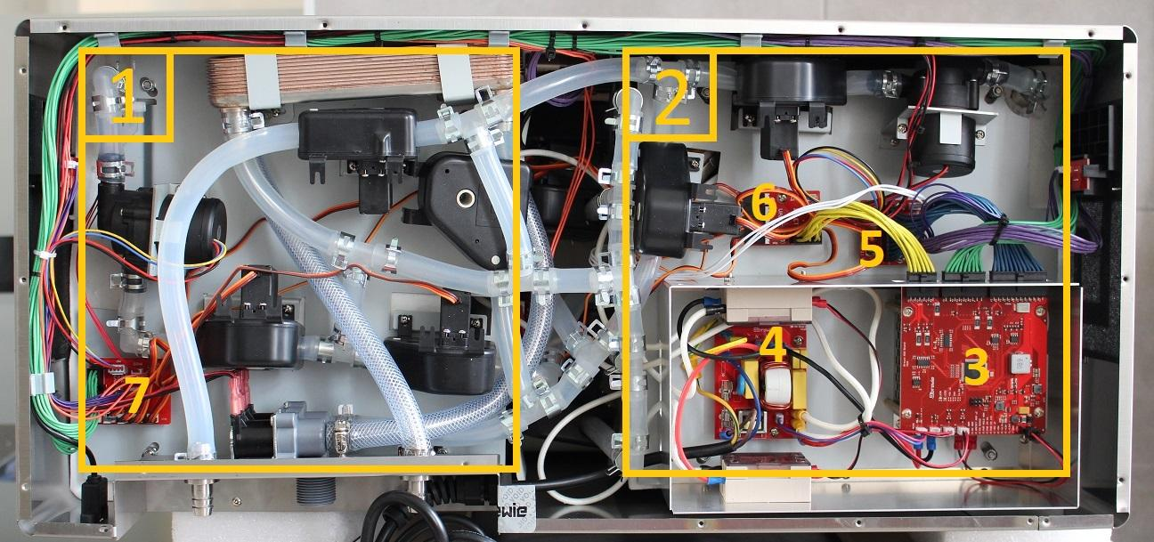

The printed circuit bords (PCBs) are located on these plates.

#3: MCU unit

#4: High voltage PCB

#5: Mash PCB

#6: Hop PCB

#7: Boil PCB

**The MCU unit**

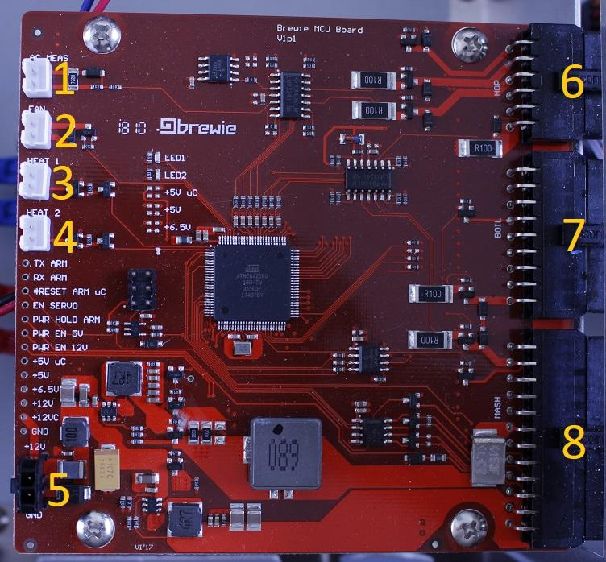

#1: Cable-G: connected to the high voltage PCB

#2: Fan 1

#3: Boil heater SSR: connected directly to the rear SSR

#4: Mash heater SSR: connected directly to the front SSR

#5: 12V power cable: connected to the power supply under the MCU

#6: Hop PCB

#7: Boil PCB

#8: Mash PCB

**Valve order**

Valves 1-4 are connected to the mash PCB.

Valves 6-9 are connected to the hop PCB.

Valves 10-11 are connected to boil PCB.

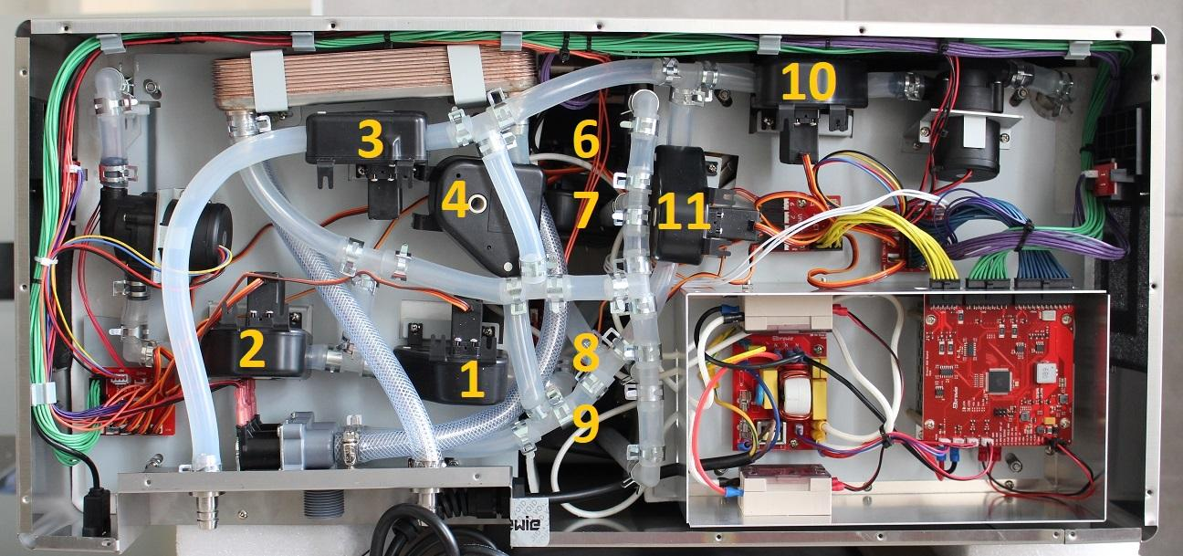

**Mash PCB**

Connections to the mash side PCB

TEMP: Mash side temperature sensor

MASS: Pressure meter

PUMP: Mash pump

LED+BTN: Drain button

VALVE 1-4: see above.

BLACK connector: Main cable from MCU

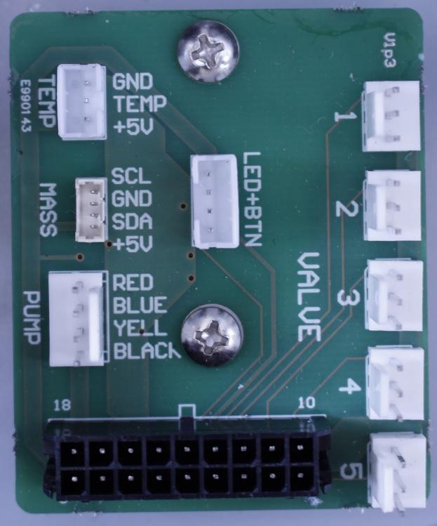

**Boil PCB**

Connections to the boil side PCB

TEMP: Boil side temperature sensor

PUMP: Boil pump

LED+BTN: Power button

VALVE 10-11: see above.

Long BLACK vertical connector: Main cable from MCU

Short horizontal BLACK ARM connector: Main cable to Front Panel

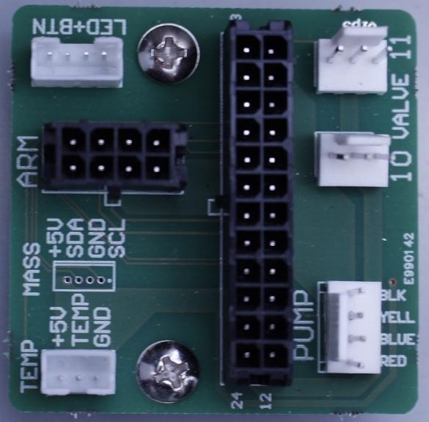

**Hop PCB**

Connections to the boil side hop PCB

VENT: Fan

INLET 1: Lower inlet of the magnetic valve

INLET 2: Upper inlet of the magnetic valve

LED+BTN: Power button

VALVE 6-9: see above.

BLACK connector: Main cable from MCU

